GATE 0 - PROJECT SYNOPSIS
Themes 1-5 | System / Tool / Engine based Mini Projects

Team No. | 4
Theme No. | 2
Project Title | Multi-Process Search Engine with Persistent Index
Guide Name | Ms. Umadevi F M
Team Members | 1. Aditya Gavimath  2. Arun Hadimani  3. Kartik Hegde  4. Prajwal V B

1. Background & Motivation
In today's digital world, large volumes of information are generated and stored in documents, files, and databases. Retrieving relevant information efficiently from this growing data is a major challenge. Traditional search systems often perform indexing and searching sequentially within a single process. As the volume of data increases, this approach can lead to higher execution time, inefficient resource utilization, and slower query responses.
A Multi-Process Search Engine with Persistent Indexing aims to overcome these limitations by using multiple independent processes to perform indexing and searching concurrently.
Our project, PaperLens, applies this idea to computer-science research papers: parallel reader processes prepare papers and citations, a persistent index stays consistent even after a crash, and search combines keyword, semantic and citation signals.

2. Project Objectives
1. Build a multi-process pipeline that collects paper records and citations and prepares them in parallel.
2. Design a persistent on-disk index that survives crashes and restarts without being left half-written.
3. Use process synchronization and logging so several reader processes and one writer update the index safely.
4. Create a search component that combines keyword, semantic and citation signals to return top-k results.
5. Set up a process manager that recovers worker crashes automatically, and evaluate search quality.

FOUNDATION COURSE INTEGRATION & CONCEPTUAL VIEW
Gate 0 - Themes 1-5
3. Foundation Course Integration
Sl. No. | Foundation Course | Broad Concepts / Areas Expected to be Applied | Role
1 | Operating Systems | Multi-process design, inter-process communication (shared memory, queues), synchronization, process supervision and restart, file durability (fsync) | Dominant
2 | Database Management Systems | Write-ahead logging, atomic commit, crash recovery, on-disk index organisation, consistent reads during writes, compaction | Dominant
3 | Data Structures and Algorithms | Inverted index, tokenization, BM25 ranking, heaps for top-k retrieval, hashing (Bloom filter, MinHash), graph ranking (PageRank) | Dominant
4 | Computer Networks | HTTP communication with arXiv and OpenAlex, request rate limiting and retries, politeness towards public services | Supporting
5 | Discrete Mathematics | Graph theory (citation graph), set similarity (near-duplicate detection), probability behind hashing and ranking | Supporting
6 | Software Engineering | Modular multi-engine design, sprint-based delivery, requirement traceability, integration and crash testing | Supporting
4. Conceptual Workflow / System View
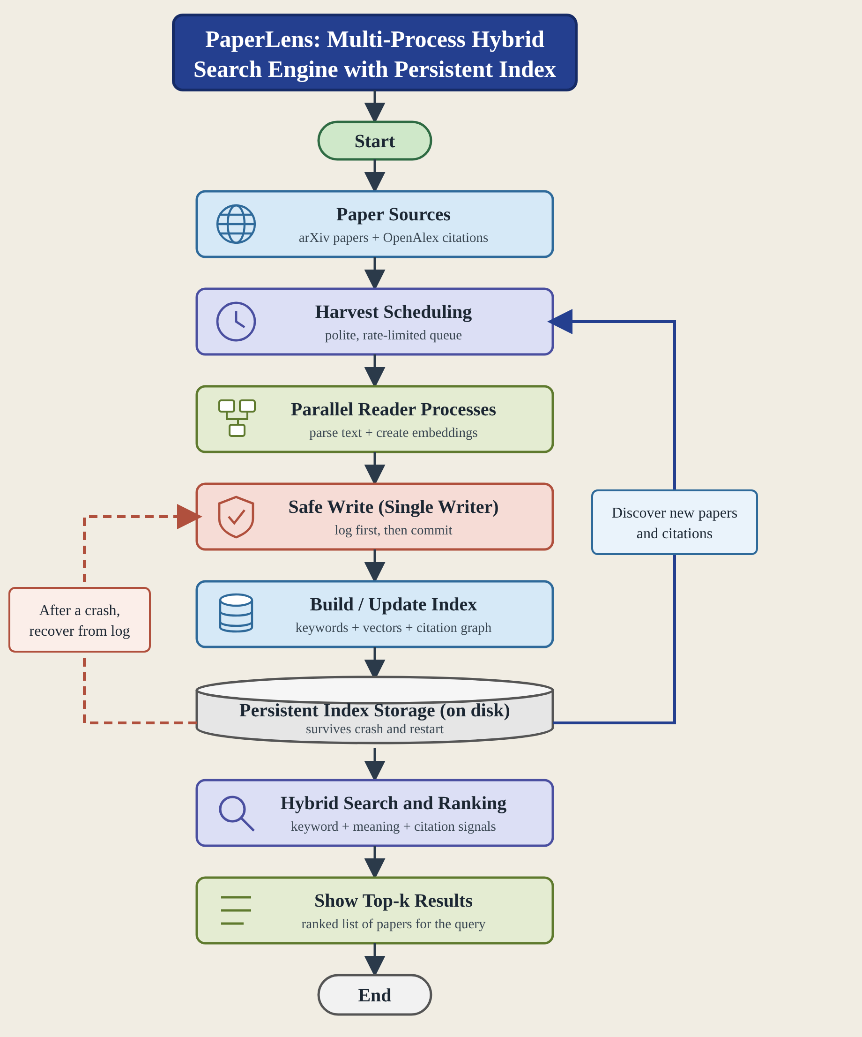

SCOPE & FEASIBILITY
Gate 0 - Themes 1-5
5. Broad Project Scope
5.1 Broadly In Scope
# | Broad In-Scope Item
1 | Harvesting CS papers from arXiv and citations from OpenAlex for a bounded subject
2 | Persistent on-disk index with logging and crash recovery
3 | Parallel readers with synchronized single-writer updates
4 | Keyword, semantic and citation ranking with top-k query and evaluation
5.2 Out of Scope
# | Out-of-Scope Item | Reason
1 | Full text of millions of papers | Too heavy for one semester; titles and abstracts are used.
2 | Production-grade UI/UX | The project focuses on core system design and algorithms, so a command-line interface is enough.
3 | Distributed multi-machine processing | The theme targets multi-process design on a single system rather than multi-machine networking.
6. Feasibility & Constraints
Feasibility within 3-credit scope | Feasible with controlled scope: a bounded set of CS papers (one subject area and date range) and a few reader processes. Multi-process ingestion, crash-safe persistence, indexing and hybrid ranking can be demonstrated without large-scale deployment.
Required computing / resources | Student laptop/PC with 8+ GB RAM, enough disk space and internet access; Python 3.10+, a free local embedding model, and open data from arXiv and OpenAlex.
Prerequisite knowledge | Basic Operating Systems, DBMS, Data Structures and Algorithms, Computer Networks, Discrete Mathematics and Python; processes, IPC, logging and recovery, hashing, graphs and basic information retrieval.
Major constraints / limitations | Limited computing power and bandwidth cap the number of papers and processes; arXiv and OpenAlex rate limits apply; abstracts alone may limit ranking quality; crash behaviour needs deliberate fault-injection tests.
Use of existing libraries / tools | Libraries may be used for HTTP, parsing, embeddings and arrays. Multi-process coordination, logging and recovery, index storage, BM25, rank fusion and citation ranking will be implemented by the students.
Overall feasibility | Feasible

